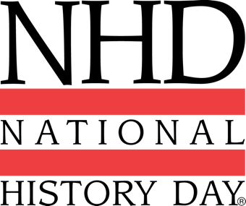
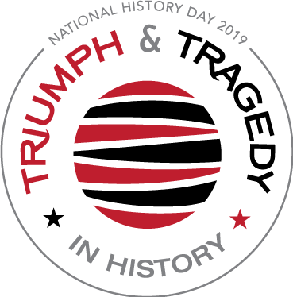
2019 NHD Theme
Triumph & Tragedy in History

DISCOVER YOUR POTENTIAL!
Enter the Buffalo Public Schools History Day Contest

Friday, February 8, 2019
Buffalo history Museum
9:00am - 1:00 p.m.

Buffalo Public Schools History Day, a year-long educational program sponsored by the Buffalo Public Schools Department of Social Studies and the Buffalo History Museum, it encourages students to explore local, state, national, and world history. After selecting a historical topic that relates to an annual theme, students conduct extensive research by using libraries, archives, museums, and oral history interviews. They analyze and interpret their findings, draw conclusions about their topics' significance in history, and create final projects that present their work. These projects can be entered into a series of competitions, from the local to the national level, where they are evaluated by professional historians and educators.

Students can compete in one of 5 project categories:
- Historical Paper (Individual only) Two Divisions
- Exhibit Junior Division: Grades 6-8
- Performance Senior Division: Grades 9-12
- Website
- Documentary

This contest is FREE for BPS Students. Click Here to Register Today
Questions? Email Megan MacNeill at MMACNEILL@BUFFALOHISTORY.ORG
Deadline to register: Friday February 1, 2019 at 5:00 p.m.
For more information about the BPS History Day program:
https://www.wnyhistoryday.com/bps-history-day.html

https://www.wnyhistoryday.com/resources.html
