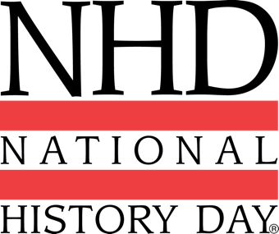
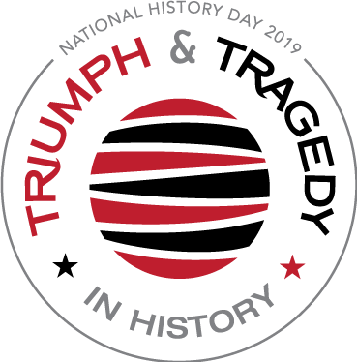
2019 NHD Theme
Triumph & Tragedy in History

DISCOVER YOUR POTENTIAL!
Enter the Western New York History Day Contest

Saturday, March 9, 2019
Canisius College Science Building
9:00am - 2:00 p.m.

Western New York History Day, a year-long educational program proudly sponsored by the Niagara Frontier Council of Social Studies (NFCSS) & Canisius College, it encourages students to explore local, state, national, and world history. After selecting a historical topic that relates to an annual theme, students conduct extensive research by using libraries, archives, museums, and oral history interviews. They analyze and interpret their findings, draw conclusions about their topics' significance in history, and create final projects that present their work. These projects can be entered into a series of competitions, from the local to the national level, where they are evaluated by professional historians and educators.

Students can compete in one of 5 project categories:
- Historical Paper (Individual only) Two Divisions
- Exhibit Junior Division: Grades 6-8
- Performance Senior Divisions: Grades 9-12
- Website
- Documentary

Questions? Email Marianne Dixon at mdixon@buffaloschools.org
Deadline to register: Friday March 1, 2019 at 11:59 p.m.
https://www.wnyhistoryday.com/registration.html
For more information about the WNY History Day program:

https://www.wnyhistoryday.com

https://www.wnyhistoryday.com/resources.html
